[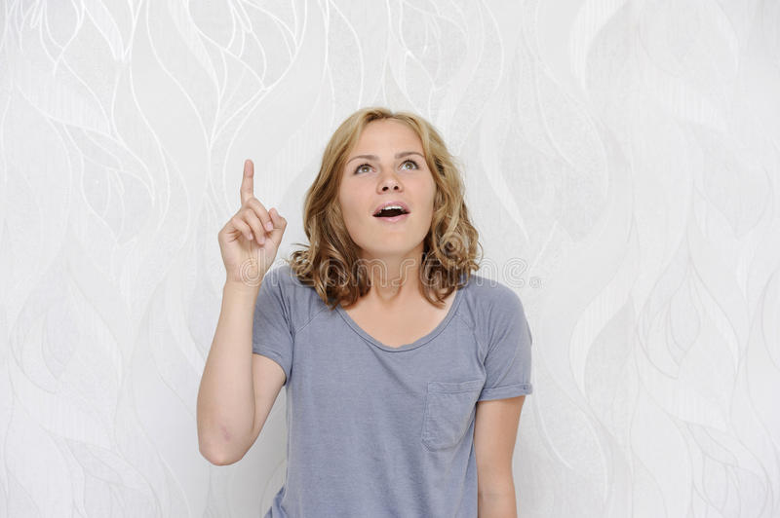](https://www.google.nl/url?sa=i&rct=j&q=&esrc=s&source=images&cd=&cad=rja&uact=8&ved=2ahUKEwib5Lqe8KDZAhWMr6QKHUcTD-UQjRx6BAgAEAY&url=https://www.dreamstime.com/stock-photo-young-woman-getting-idea-showing-index-finger-surprise-image54469028&psig=AOvVaw0ipdB_SwAql1MDaM29gDCZ&ust=1518541977833149) [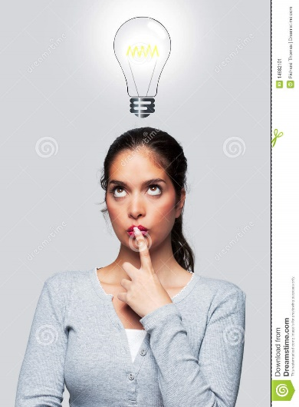](https://www.google.nl/url?sa=i&rct=j&q=&esrc=s&source=images&cd=&cad=rja&uact=8&ved=2ahUKEwjTkJa58KDZAhWCr6QKHYN1DWIQjRx6BAgAEAY&url=https://www.dreamstime.com/stock-image-women-bright-idea-image14682101&psig=AOvVaw0ipdB_SwAql1MDaM29gDCZ&ust=1518541977833149)

het idee nadenken

[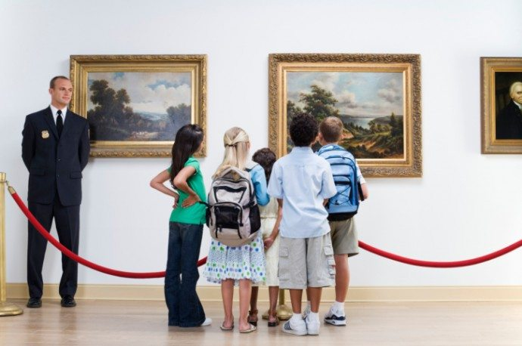](http://www.google.nl/url?sa=i&rct=j&q=&esrc=s&source=images&cd=&cad=rja&uact=8&ved=2ahUKEwjE6JGO8aDZAhXB6qQKHeEzB70QjRx6BAgAEAY&url=http://www.me-to-we.nl/waarom-je-niet-naar-het-museum-moet-met-kleine-kinderen-aldus-martijn/&psig=AOvVaw1paQPNmjiwzl2VCe_K2ZhT&ust=1518542178915438) [](http://www.google.nl/url?sa=i&rct=j&q=&esrc=s&source=images&cd=&cad=rja&uact=8&ved=2ahUKEwijvL_R8aDZAhWLqaQKHY0VBMgQjRx6BAgAEAY&url=http://happysinglemoms.nl/alleen-zn-tweeen/&psig=AOvVaw3r7qVcWZj3uabb3eFuU654&ust=1518542440276584)

het museum samen

[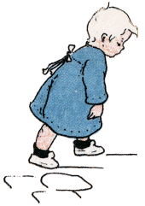](http://www.google.nl/url?sa=i&rct=j&q=&esrc=s&source=images&cd=&cad=rja&uact=8&ved=2ahUKEwj_zcWJ8qDZAhWFDuwKHWKfBcoQjRx6BAgAEAY&url=http://fairy-tales.clubs.nl/nieuws/detail/627744_hansje&psig=AOvVaw2nzkLeiPFTyqRs1lWzbvQO&ust=1518542530407918) [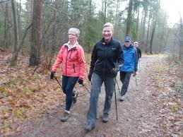](https://www.google.nl/imgres?imgurl=http://www.gach.nl/uploads/nieuws/3529_nordic-basiscursus-mrt-2017_large.jpg&imgrefurl=http://www.gach.nl/nieuws/nooit-meer-sjokken/&docid=3uMKuc6SffRmPM&tbnid=_8rDnWxM70a-XM:&vet=10ahUKEwiEnfHx8aDZAhXIzaQKHVy1CcMQMwhlKB4wHg..i&w=640&h=480&itg=1&bih=932&biw=1920&q=sjokken&ved=0ahUKEwiEnfHx8aDZAhXIzaQKHVy1CcMQMwhlKB4wHg&iact=mrc&uact=8)

sjokken doorlopen

[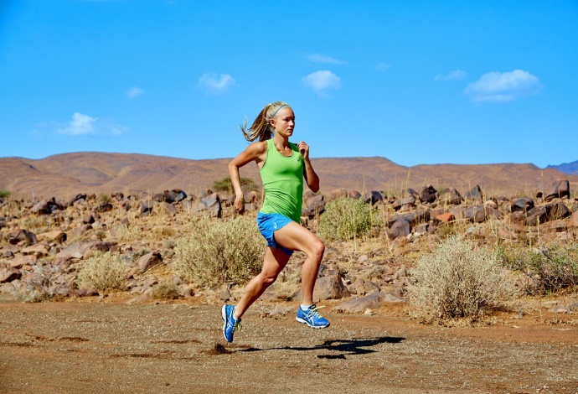](http://www.google.nl/url?sa=i&rct=j&q=&esrc=s&source=images&cd=&cad=rja&uact=8&ved=2ahUKEwjtg8Kr8qDZAhVS6KQKHWHYCiwQjRx6BAgAEAY&url=http://www.eatrunlove.nl/hardlopen-looptechniek-2/&psig=AOvVaw2nzkLeiPFTyqRs1lWzbvQO&ust=1518542530407918) [](https://www.google.nl/url?sa=i&rct=j&q=&esrc=s&source=images&cd=&cad=rja&uact=8&ved=2ahUKEwir_s_l8qDZAhWK-KQKHdnvA40QjRx6BAgAEAY&url=https://www.zaandewandel.nl/editie-2017/&psig=AOvVaw18p28w84OFUg2qzv5vCKry&ust=1518542742804689)

hardlopen/ rennen lopen

[](http://www.google.nl/url?sa=i&rct=j&q=&esrc=s&source=images&cd=&cad=rja&uact=8&ved=2ahUKEwiMiIGL86DZAhXOzqQKHfP9CgwQjRx6BAgAEAY&url=http://momsandmore.be/tips-tricks/tips-voor-meer-energie/&psig=AOvVaw38b-qe6588OfTrkLwDidPT&ust=1518542820592525) [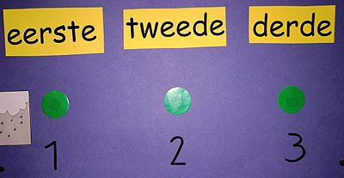](http://www.google.nl/url?sa=i&rct=j&q=&esrc=s&source=images&cd=&cad=rja&uact=8&ved=2ahUKEwjSwJuz86DZAhXS-aQKHbzeCagQjRx6BAgAEAY&url=http://woorden.wiki.kennisnet.nl/Derde&psig=AOvVaw3rSGbLxqaY0yvbbvZz3uXo&ust=1518542907578558)

moe eerste /tweede/ derde

[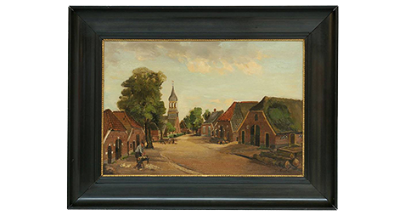](http://www.google.nl/url?sa=i&rct=j&q=&esrc=s&source=images&cd=&cad=rja&uact=8&ved=2ahUKEwju7tPe86DZAhUS3qQKHRLPAVkQjRx6BAgAEAY&url=http://dewiezer.nl/nieuws/algemeen/de-dorpsstraat-door-van-kregten&psig=AOvVaw1LkWpGxo6IWENdfPDEJeAa&ust=1518542992493688)

het schilderij / de lijst

[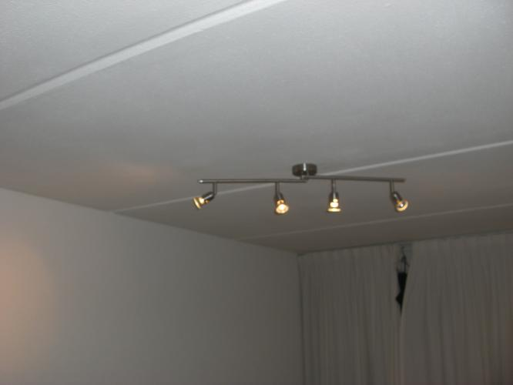](https://www.google.nl/url?sa=i&rct=j&q=&esrc=s&source=images&cd=&cad=rja&uact=8&ved=2ahUKEwir2MKz-qDZAhUD-6QKHSLsDlEQjRx6BAgAEAY&url=https://www.werkspot.nl/opdracht/362850/plafond-stuccen&psig=AOvVaw1FdUxSEgzgjg83Q-9d245I&ust=1518544754407969) [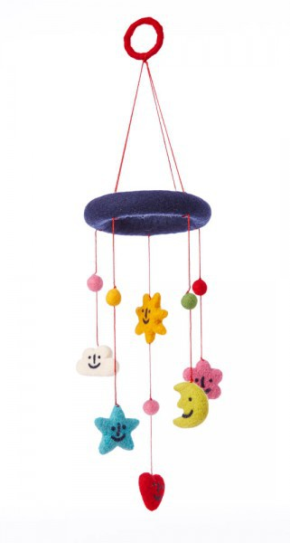](https://www.google.nl/url?sa=i&rct=j&q=&esrc=s&source=images&cd=&cad=rja&uact=8&ved=2ahUKEwiEppT--qDZAhXJF-wKHQQ1CKUQjRx6BAgAEAY&url=https://www.allesisliefde.com/c-3304193/klippan-mobiel/&psig=AOvVaw29GhhEuv5AhGLvBNa-azrh&ust=1518544886893792)

het plafond de mobiel

[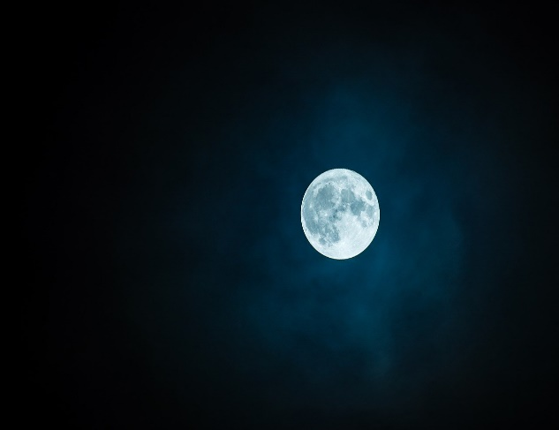](https://www.google.nl/url?sa=i&rct=j&q=&esrc=s&source=images&cd=&cad=rja&uact=8&ved=2ahUKEwiort-k-6DZAhXHF-wKHYFYBzMQjRx6BAgAEAY&url=https://www.scientias.nl/mogelijk-lavatunnels-ontdekt-noordpool-maan/&psig=AOvVaw1XXDIh1sjSVhVMyVFkObDa&ust=1518545041442481) [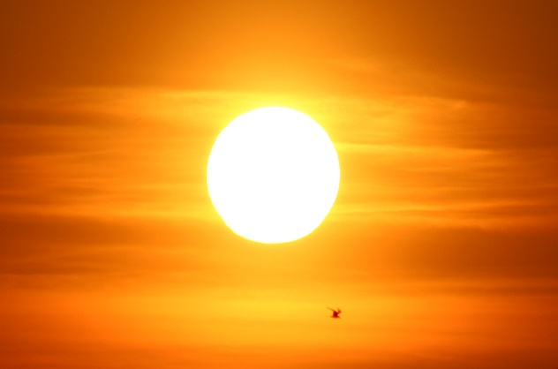](http://www.google.nl/url?sa=i&rct=j&q=&esrc=s&source=images&cd=&cad=rja&uact=8&ved=2ahUKEwjmt_fB-6DZAhWDCOwKHXDqD7cQjRx6BAgAEAY&url=http://numrush.nl/2016/06/07/kunstmatige-bladeren-kunnen-brandstof-maken-van-water-en-zon/&psig=AOvVaw1f5A8PL-yKpaFaotcw4a2w&ust=1518545080429175)

de maan de zon

[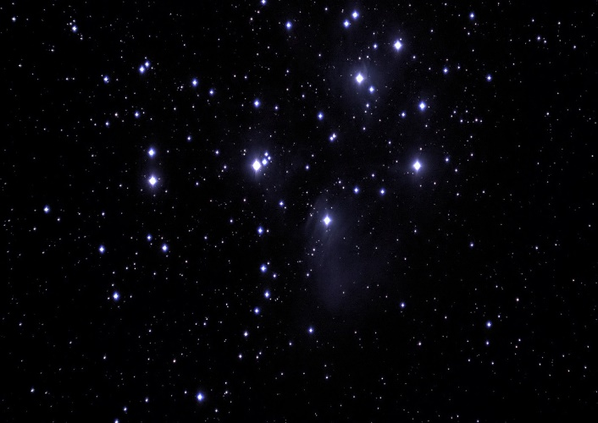](https://www.google.nl/url?sa=i&rct=j&q=&esrc=s&source=images&cd=&cad=rja&uact=8&ved=2ahUKEwiI69bk-6DZAhVJ6KQKHdFgAaoQjRx6BAgAEAY&url=https://www.artis.nl/nl/ontdek/verhalen/zes-stappen-door-het-heelal/&psig=AOvVaw3F2MEgIZ8kaL55VjZudCCX&ust=1518545180238792) [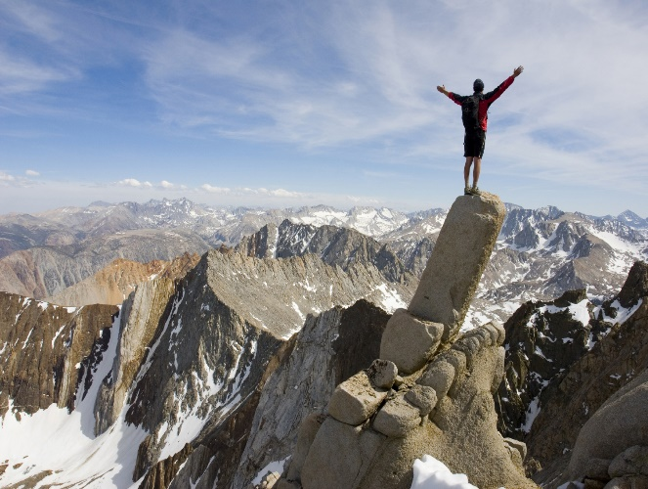](http://www.google.nl/url?sa=i&rct=j&q=&esrc=s&source=images&cd=&cad=rja&uact=8&ved=2ahUKEwjxvYGH_KDZAhXD_qQKHRcNAU4QjRx6BAgAEAY&url=http://www.whitehallpartnership.co.uk/blog/pension-investments-can-improve-your-health&psig=AOvVaw0f3XcHcLjIjWASvyLmIfc6&ust=1518545218212209)

de sterren de top

[](https://www.google.nl/url?sa=i&rct=j&q=&esrc=s&source=images&cd=&cad=rja&uact=8&ved=2ahUKEwiF3s-o_KDZAhWHyqQKHbLfDT0QjRx6BAgAEAY&url=https://www.behangwereld.nl/c-3712898/grijs-behang/&psig=AOvVaw3Bb0TSg4nxGjlhCT5xZDf2&ust=1518545323904783)’ [](https://www.google.nl/url?sa=i&rct=j&q=&esrc=s&source=images&cd=&cad=rja&uact=8&ved=2ahUKEwie2ZDh_KDZAhUIKewKHYdcDkAQjRx6BAgAEAY&url=https://www.aduis.nl/transparantpapier-70-x-100-cm,-geel-art604111.aspx&psig=AOvVaw3UV3ozLDr63AvKd2mt9991&ust=1518545421664986)

grijs geel

[](https://www.google.nl/url?sa=i&rct=j&q=&esrc=s&source=images&cd=&cad=rja&uact=8&ved=2ahUKEwj9jYqB_aDZAhWMC-wKHTcHBb8QjRx6BAgAEAY&url=https://tuf-tuf.nl/feest-op-kleur/blauw/&psig=AOvVaw2TLuvgbwk2MMpotGKcUgrc&ust=1518545505692753) [](http://www.google.nl/url?sa=i&rct=j&q=&esrc=s&source=images&cd=&cad=rja&uact=8&ved=2ahUKEwij1sGd_aDZAhWD-qQKHUSsCrAQjRx6BAgAEAY&url=http://www.beeldbalie.nl/betekenis-van-kleur/&psig=AOvVaw1-c2Pknw_Go5HzUOrAJwZ2&ust=1518545555871987)

blauw de kleur / de kleuren

[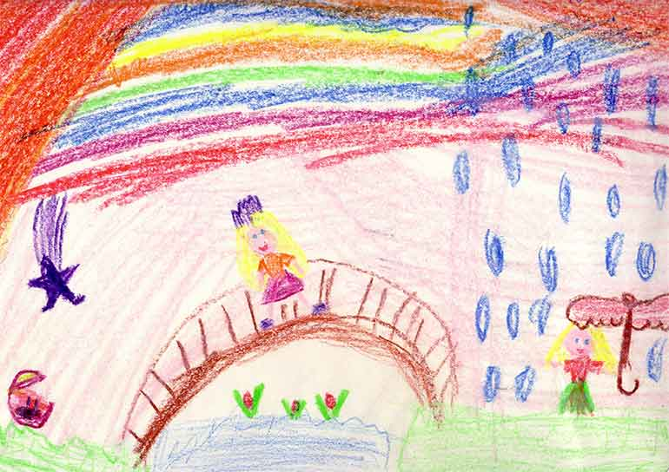](http://www.google.nl/url?sa=i&rct=j&q=&esrc=s&source=images&cd=&cad=rja&uact=8&ved=2ahUKEwiE-s_g_aDZAhVODuwKHe7ADvEQjRx6BAgAEAY&url=http://kindertekeningen.blogspot.com/p/ontwikkelingen-van-tekeningen.html&psig=AOvVaw1AYFOtLojaUy8muhcqS5yR&ust=1518545707387519) [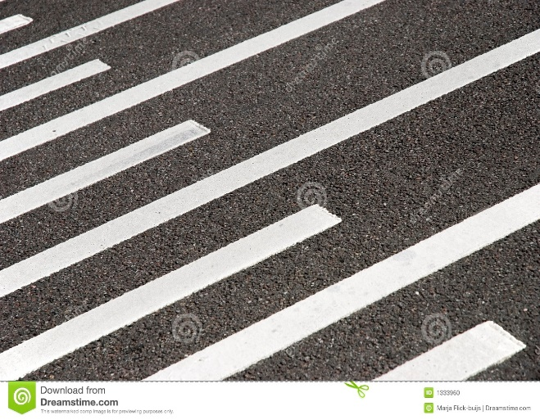](https://www.google.nl/url?sa=i&rct=j&q=&esrc=s&source=images&cd=&cad=rja&uact=8&ved=2ahUKEwjUjtWh_qDZAhVNDewKHYMXCMkQjRx6BAgAEAY&url=https://nl.dreamstime.com/stock-foto-de-strepen-van-de-bestrating-image1333960&psig=AOvVaw0GvLEic3fes0gwQZGBfK8G&ust=1518545829234410)

de tekening de streep / de strepen

[](http://www.google.nl/url?sa=i&rct=j&q=&esrc=s&source=images&cd=&cad=rja&uact=8&ved=2ahUKEwi1mr_jj6HZAhVS66QKHYiGDM8QjRx6BAgAEAY&url=http://www.kleuteridee.nl/gym-beweging/lessen-met-banken/&psig=AOvVaw15RZ-Wk4Lcd0HNhWisN5qA&ust=1518550511537677) [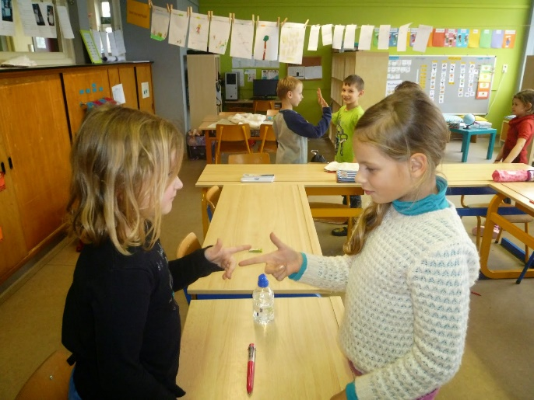](http://www.google.nl/url?sa=i&rct=j&q=&esrc=s&source=images&cd=&cad=rja&uact=8&ved=2ahUKEwjK0uO3kKHZAhVF16QKHdsaCrYQjRx6BAgAEAY&url=http://klasmarjan.blogspot.com/2015/02/spiegelingen-carnaval-op-school.html&psig=AOvVaw0FDm9HHq8hgVTLjwdCb58U&ust=1518550722984415)

naast elkaar tegenover elkaar

[](http://www.google.nl/url?sa=i&rct=j&q=&esrc=s&source=images&cd=&cad=rja&uact=8&ved=2ahUKEwjCo87MkaHZAhURzKQKHRuCBq4QjRx6BAgAEAY&url=http://www.carmendeveer.com/TT_1.html&psig=AOvVaw3T4ok_9Ek_1wzmxmDYeC5e&ust=1518551032725874) 

recht schuin

[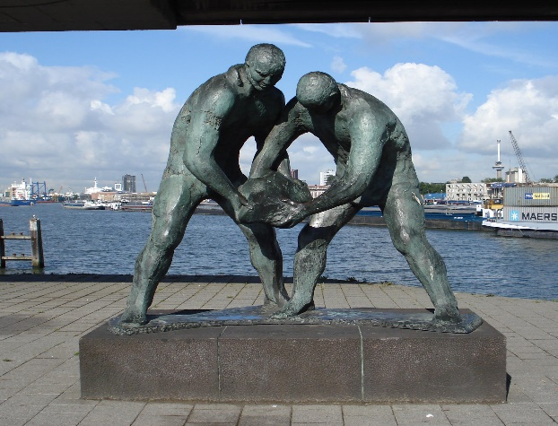](https://www.google.nl/url?sa=i&rct=j&q=&esrc=s&source=images&cd=&cad=rja&uact=8&ved=2ahUKEwiZkrT6kqHZAhVN16QKHWEeCs0QjRx6BAgAEAY&url=https://commons.wikimedia.org/wiki/File:Rotterdam_kunstwerk_dijkwerkers.jpg&psig=AOvVaw3HLjd268CRoh1Y7-rIfqXs&ust=1518551368721233) [](https://www.google.nl/url?sa=i&rct=j&q=&esrc=s&source=images&cd=&cad=rja&uact=8&ved=2ahUKEwjXn5Kdk6HZAhVDzKQKHbghCkMQjRx6BAgAEAY&url=https://forums.hababam.nl/archive/index.php/t-134763-vrouw-knipt-penis-van-man-af-hij-heeft-het-verdiend.html&psig=AOvVaw1iM5fYgaPib4S6mFWiGZoZ&ust=1518551474108804)

het beeld de schaar

[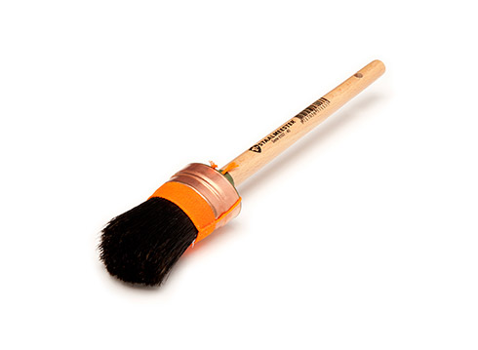](http://www.google.nl/url?sa=i&rct=j&q=&esrc=s&source=images&cd=&cad=rja&uact=8&ved=2ahUKEwjVxMjCk6HZAhUD-6QKHSLsDlEQjRx6BAgAEAY&url=http://www.staalmeester.com/&psig=AOvVaw1V_xEbdAWg6SD8nQgm0VCA&ust=1518551526657956) [](https://www.google.nl/url?sa=i&rct=j&q=&esrc=s&source=images&cd=&cad=rja&uact=8&ved=2ahUKEwjW4ajek6HZAhXS3KQKHWYGB04QjRx6BAgAEAY&url=https://nl.dreamstime.com/royalty-vrije-stock-afbeelding-vector-realistisch-penseel-image40697556&psig=AOvVaw0-tOHpqj30kWASYvYAE7yI&ust=1518551584248466)

de kwast de penseel

[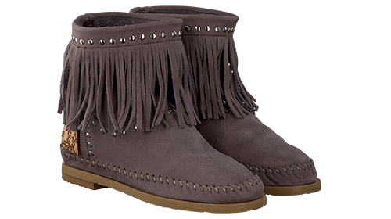](https://www.google.nl/url?sa=i&rct=j&q=&esrc=s&source=images&cd=&cad=rja&uact=8&ved=2ahUKEwierYKNlKHZAhWPyKQKHVfQAKwQjRx6BAgAEAY&url=https://www.lindanieuws.nl/lifestyle/win-een-paar-schoenen-van-karma-of-charme-t-w-v-e-16995/&psig=AOvVaw3WXw3qpekEzv8RWb3muLex&ust=1518551686044552) [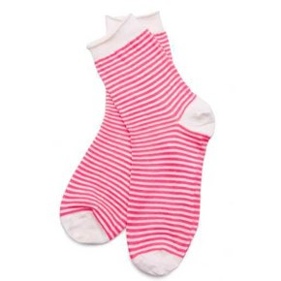](http://www.google.nl/url?sa=i&rct=j&q=&esrc=s&source=images&cd=&cad=rja&uact=8&ved=2ahUKEwj62seclKHZAhXQyqQKHUgkCT8QjRx6BAgAEAY&url=http://4plaatjes1woord.net/antwoord-87/&psig=AOvVaw3-ZtFmKmbhgGKR4l4U7nno&ust=1518551737754273)

een paar schoenen een paar sokken

[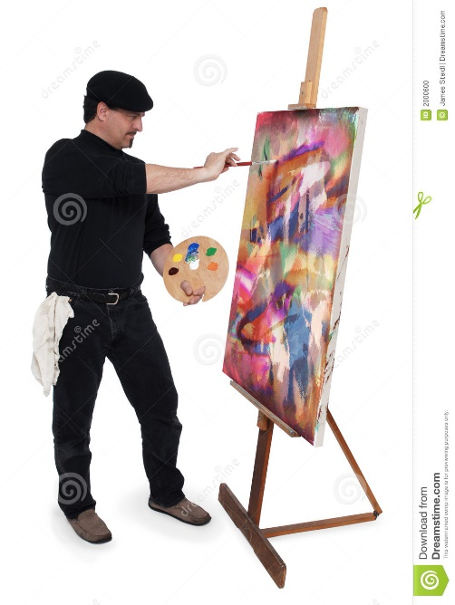](https://www.google.nl/url?sa=i&rct=j&q=&esrc=s&source=images&cd=&cad=rja&uact=8&ved=2ahUKEwiol8r3lKHZAhUPzKQKHfOUCLIQjRx6BAgAEAY&url=https://nl.dreamstime.com/stock-foto-de-kunstenaar-image2000600&psig=AOvVaw1HYWcD4x3JoDMoBu9qA6B-&ust=1518551803906302)

de kunstenaar